Unit 7 Vocabulary
Word | Definition | Picture/Example
Atmosphere
Air Pressure
Wind
Sea Breeze | When cool air rushes from the SEA to land because it is hotter on the land. This happens during the day | 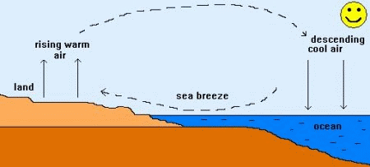
Land Breeze | When cool air rushes from the LAND to the sea because it is hotter on the water. This happens at night. | 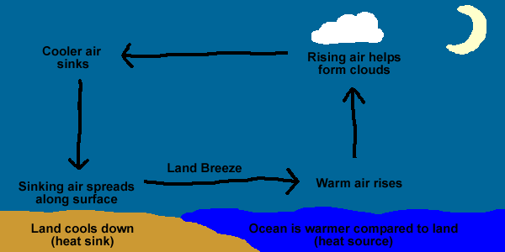
Coriolis Effect
Global Winds | Winds that happen constantly including the polar easterlies, trade winds and westerlies | 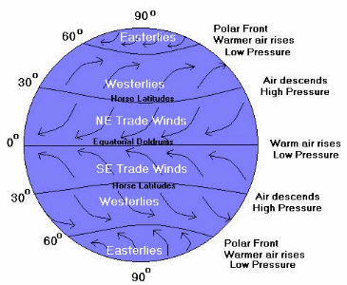
Greenhouse Effect
Global Warming
Convection
Radiation
Conduction
Acid Precipitation
Barometer
Air Mass | air mass is a volume of air defined by its temperature and water vapor content. Air masses cover many hundreds or thousands of square miles, and adapt to the characteristics of the surface below them. They are classified according to latitude and their continental or maritime source regions.
Tropical Air Mass | An air mass formed over an area close to the equator. Contains warm/hot air
Polar Air Mass | An air mass formed over an area close to the polar regions. Contains cool/cold air.
(Weather) Front
Cold Front | the boundary of an advancing mass of cold air, in particular the trailing edge of the warm sector of a low-pressure system
Continental Air Mass | An air mass that formed over land. Usually contains dry air.
Maritime Air mass | An air mass that formed over water. Usually contains moist air.
Hurricane
Thunderstorm
Tornado
Stationary Front | pair of air masses, neither of which is strong enough to replace the other. On a weather map, this is shown by an inter-playing series of blue spikes pointing one direction and red domes pointing the other. | 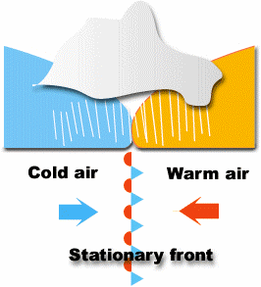
Occluded Front | occurs when a cold front overtakes a warm front. As low pressure systems develop, fronts form around it, usually a warm front ahead of it, and a cold front trailing behind | 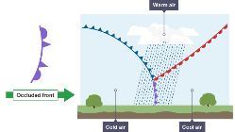
Tropical (Climate) Zone
Polar (Climate) Zone
Temperate (Climate) Zone
Blizzard | a severe snowstorm with high winds and low visibility
Lighting
Thunder
Drought | a prolonged period of abnormally low rainfall; a shortage of water resulting from this
Jet Stream
Trade Winds
Westerlies

Polar Easterlies
Prevailing Winds

