Name: _______________________________________Date: __________________________ Period: _________________
Unit 8 Part 2 Study Guide

1-3. Fill in the following BRIDGE map.

Weathering ? Deposition
? Moves sediment ?

4. Sediment is formed when rocks get ________________

5. Name 4 examples of sediments?

6. If sediments are compacted and cemented, they will eventually form ____________ rocks.

7-11. In the following tree map, fill in words that would fit:

Weathering

Mechanical _______________

root pry oxidation

___________ __________

___________ __________

Describe what happened in each picture below # 12 – 16
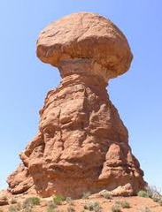

12.

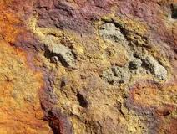
13.

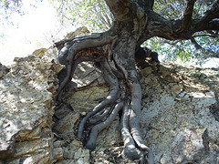

14.

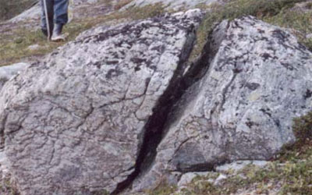

15.

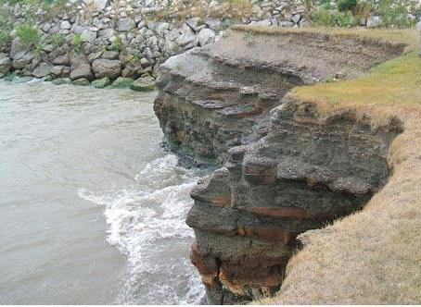
16.

17-18. Fill in the brace map about what makes up soil:

____________________

Soil Composition _____________________

______Air and water____

19. Is soil a renewable or nonrenewable natural resource? Why?

Write the word that matches each definition below for # 20 – 22 .

20. planting different crops each year (corn one year, beans the next) is ___________________________

21. making steps on the side of a mountain to slow down water erosion is __________________________

22. plant trees/bushes to slow down wind erosion is __________________________

23. What was the main cause of the Dust Bowl of the 1930’s?

24. What SHOULD have farmers done to prevent the Dust Bowl? Explain.

25. What is the name of the layer of soil just under the grass? (hint: also called the “A-horizon”)?

26. Draw a model of the soil horizons and label them.

27. (true or false) The sediments in topsoil is MORE weathered than the sediments in subsoil. Why or why not?

28. Why is topsoil so important to farming and gardening?

29. After digging deeper and deeper, you would eventually hit solid (unweathered) rock, called _______________.

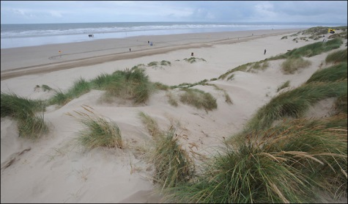

30. How was this sandbar made?

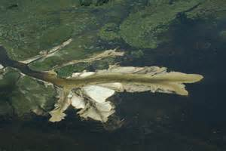
31. A(n) ________________ is a pile of
sediment left at the
mouth of a river.

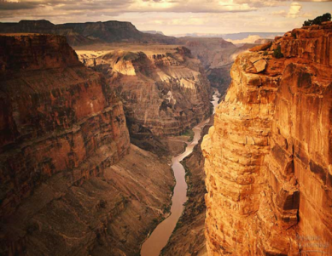
32. Explain how this canyon formed.

33. Describe how an alluvial fan is made and draw a picture.

34. Describe how a till deposit is made and draw a picture.

35. Create the weathering tree map including pictures

36. Create the erosion tree map including pictures

