Name: _____________________________________________ Date: _______________ Period: ___________
Unit 8: Astronomy Remediation
Part 1 – Seasons
- What causes Earth to have seasons?

- How long is Earth’s rotation?

- How long is Earth’s revolution?

- If the Earth didn’t have seasons, what can you conclude about the Earth itself?

Part 2 – Early Models
  - Fill in the double bubble in comparing and contrasting Heliocentric and Geocentric theories.
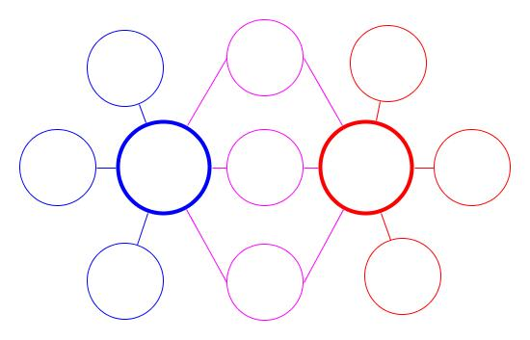
9. According to the big bang theory, how old is our universe?

10. What does the Big Bang Theory state about our universe?

Part 3 – Galaxies
11. What is the name of our galaxy? What does it look like?

12 - 14. Complete the tree map to classify the three types of galaxies. Make sure you draw a picture of each.
GALAXIES

______________ _______________ ______________
Usually young stars Usually old Stars Our Galaxy

15. Where are we located in our galaxy?

Part 4 – Planets
16. What are the planets in order, starting from the Sun?

17. What two forces allow the planets to stay in their orbit? Describe each.

18. Describe the inner planets with at least 7 descriptive adjectives

Part 5—Outer planet
19. Describe EACH of the outer planets
1.

2.

3.

4.

Part 8—Other objects in our solar system
Matching:
_____20. A “dirty snowball” with a tail (from melted ice) a. meteoroid
_____21. Created when a large meteorite hits the ground b. meteor
_____22. Another name for a “shooting star” c. crater
(forms when rocks from space burn d. comet
up in our atmosphere) e. asteroid
_____23. Found in a belt between Mars and Jupiter
Part 7–Eclipses
- What type of eclipse is seen when a new moon moves in front of the sun?

- Is it safe to look at a lunar eclipse? Why or why not?

- Is this a solar or lunar eclipse? What phase of the moon would it be?
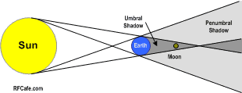

- Is this a solar or lunar eclipse? What phase of the moon would it be?
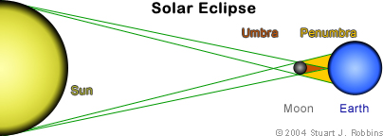

Part 6—Moon Phases

28. If the moon is getting brighter each day, we call it a _____________ moon.

29.
PHASES OF THE MOON

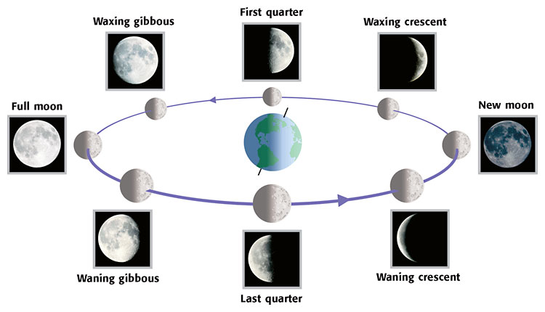
S
U
N

30. Why do we see different phases of the moon?

31. How does the moon’s revolution and rotation compare? What does this tell you about the moon itself?

32. True or False: Half of the moon is always lit
Explain why this is true or false below:
Part 7: Extra Critical Thinking

- Understand- Why do we (the Northern Hemisphere) have summer at point 3 and winter at point 1 shown in the picture?

- Why is it that in the summer and winter, we have solstices and in the fall and spring, we have equinoxes?

- Where are we located in our galaxy and what might happen if we were located somewhere else in our galaxy?

- A student witnesses an object in the sky and describes it as having a lit tail following it. What is most likely this object? What evidence do you have to support your answer?

- A rock starts in space and makes it way into the Earth’s atmosphere and finally hits the Earth’s surface. At which points does this rock change in classification? What is the order in which its name is changed?

