Name: _________________________________________ Date: _______________ Period: ____________

UPWELLING
- Upwelling occurs off the _____________________ coast of _______________________________ .

- Warm surface waters move offshore (due to ____________________ ), then deep, _______________, (nutrient ____________) water rises up to replace it.

- Creates a _______________ environment for ocean life
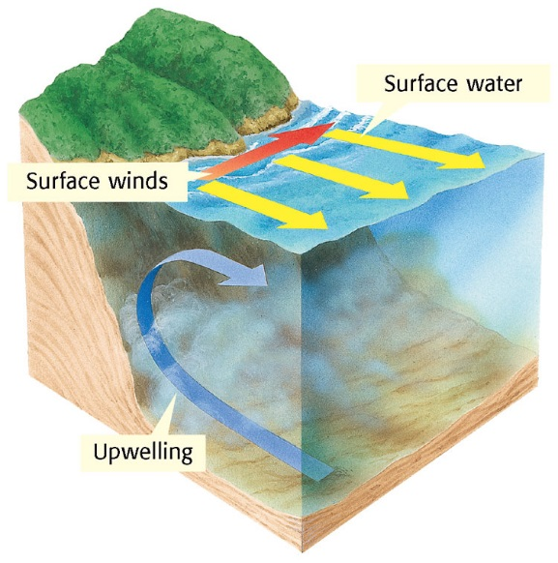
EL NINO
- Means _________________ because it starts in Peru around Christmas time

- Happens when the eastern ________________ ocean warms to ________________ degrees Fahrenheit.

- Occurs every ___________________ years (can last a year or two)

- Last one was ________________ to _____________ (VERY STRONG!)

- Some say it is due to __________________ and others say ____________________________________ (Scientists are unsure)

- Scientists have ____________________ that record sea SURFACE temperatures, air temperatures, winds and currents to predict El Nino.
  - PREDICTORS: ____________ trade winds and/or _____________ surface temperatures
Why is there usually LESS hurricanes in the U.S during El Nino years?

LA NINA
- Means ___________________ and occurs after an El Nino year

- Caused when the waters in the eastern ________________ ocean get COOLER than usual.

When could upwelling occur?

