Vocabulary Crossword
Directions
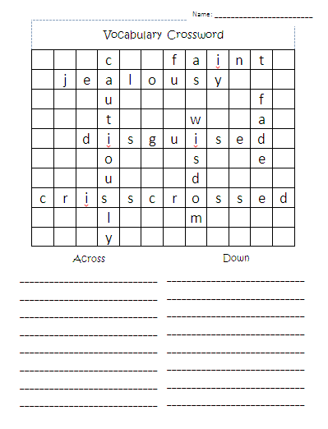  Put each of your words  into the boxes. (write lightly) | 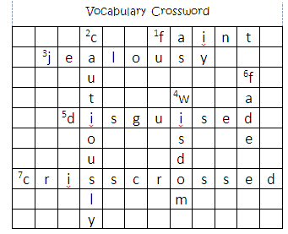  Number the first box  of each word
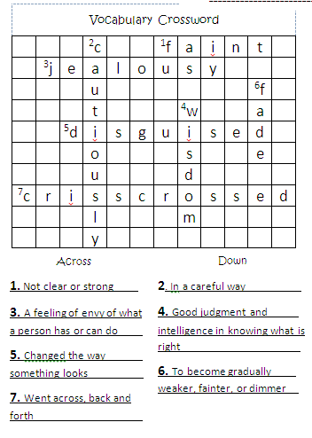  Write down the number followed by a definition/synonym for each word on the blanks below | 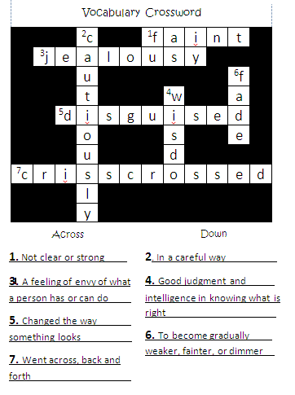  Color in the unused boxes.
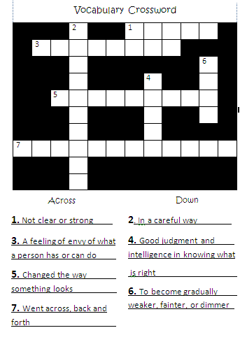
Erase the words, but leave the numbers.

Vocabulary Crossword
Name: ________________________
Down
____________________________
____________________________
____________________________
____________________________
____________________________
____________________________
____________________________
____________________________
____________________________

Across
____________________________
____________________________
____________________________
____________________________
____________________________
____________________________
____________________________
____________________________
____________________________

