H₂O Cycle & Distribution
Over ______% of Earth is covered by water.
On the back, write why water is important .
Most (_____%) of water on Earth is salty/ocean. Note: salinity is the saltiness of the water (ocean salinity is about 3-4 %)
3% of the world’s water is fresh:
>most (76%) is _____________
(icebergs and glaciers)
>a lot (23%) is ______________

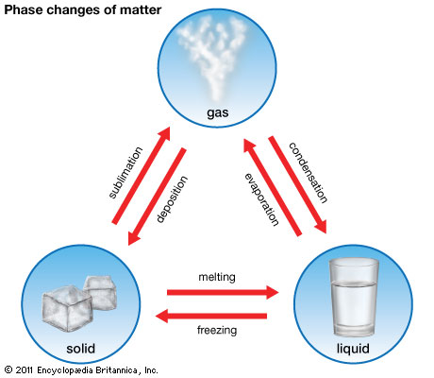
The hydrologic or water cycle is________________ movement of water through the Earth’s atmosphere and ground.
(powered by the ______________)
**Evaporation
________water changes to gas/water vapor (due to heating)
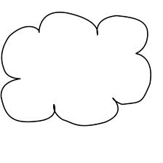
**Condensation
water vapor (gas) changes to _________ (due to cooling)—makes _____________

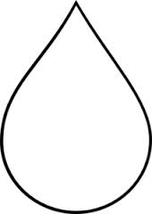
**Precipitation –liquid or solid water falls to the ground from a cloud -----
4 types:

**Surface ______________= water that does not soak into the ground (flows downhill)
**__________________=process where water soaks into the ground (also called percolation)
**_______________________ = water underground (aquifer stores the water)

**___________________=water released by plants (through their leaves)

Label the picture on the back of this sheet

The total amount of water on Earth has _________________________ since Earth was formed.
Water Conservation
The ________________ has the highest per capita use of water.
Give 3 examples of contamination of the water supply:

Give 3 examples of how to conserve water

