Name: _________________________________ Date: _____________________ Period: _______________
Weathering Matching
Match the pictures to the words in the second column for each picture. Draw a line from the picture to the description.
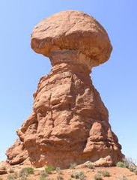

1. _____

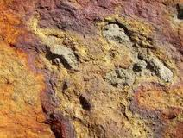
2. _____

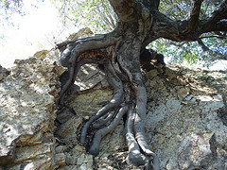

3. _____

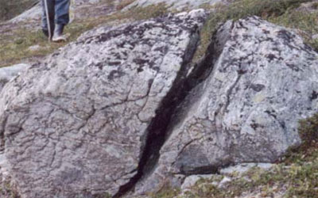

4. _____

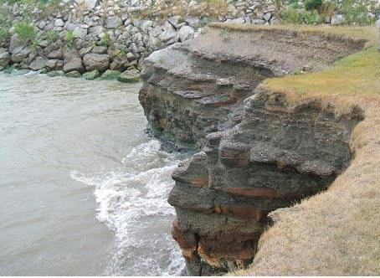

5. _____

- Mechanical: Root wedging

- Chemical: Rusting (oxidation)

- Mechanical: Water

- Mechanical: Ice wedging

- Mechanical: Abrasion (wind)

Name: _________________________________ Date: _____________________ Period: _______________
Deposition Matching
Match the pictures to the words in the second column for each picture. Draw a line from the picture to the description.

- _____ 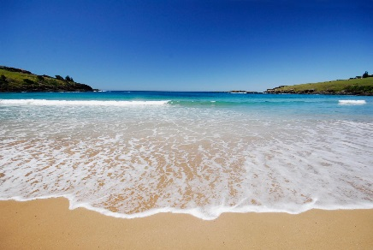
- _____ 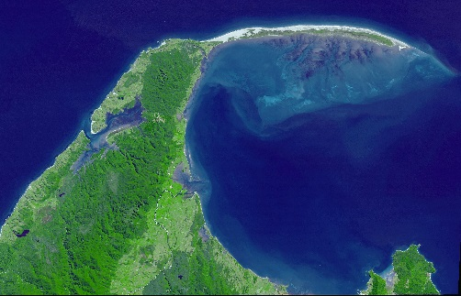
- _____ 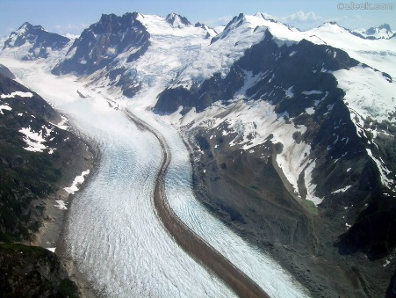
- _____ 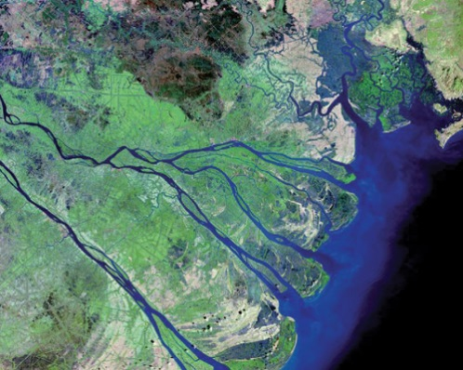
- _____ 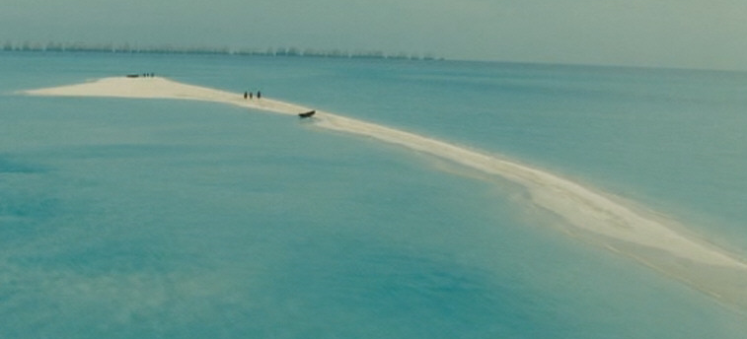
- _____ 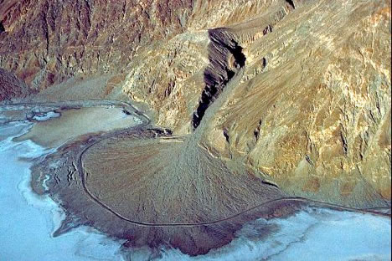

- Alluvial Fan

- Delta

- Beach

- Barrier Spit

- Sand bar

- Till deposit

