Weathering
Weathering is:
the _______________________ of rocks/minerals
at the earth’s surface to make…
- ___________ (may form sedimentary rocks)
- soil
The two main types of weathering are:
1. _____________________ (physical changes)
2. _____________________ (chemical reaction)

>>4 causes of mechanical weathering :
- _________________________ changes
  - Rocks heat up and cool down
  - Water ______________ (at night) and expands ---also called ice ___________
- _________________________ grinding and wearing away of rock by other pieces or rock.
Caused by:
  - __________________ (rivers, waves)
  - __________________
  - __________________ (hills, mountains)
- Plant growth (____________ wedging)

- ________________ (including humans)—digging, burrowing, etc)

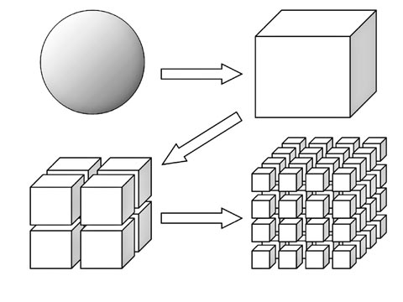

>>3 things that cause chemical weathering:

- ____________--dissolves
(can carve out caves)

- weak _____________
  - precipitation—due to volcanoes and burning ______________________
  - groundwater (carbonic acids)
  - ____________
    - Tips of roots
    - ________________

- ____________ (rust or ________________)

What makes rocks weather FASTER?
- ___________ rock
- More ________________ area
- Warm, ______________ climates
- Areas with a lot of ___________, __________ slopes, and/or windy
- Areas with large ______________ differences
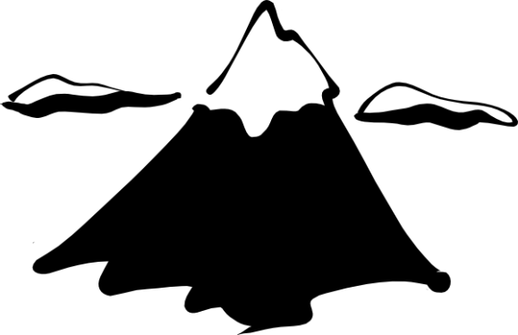
>>note: mountains have a lot of weathering.
Why is this?

