Name: ____________________________________________ Date: _________________ Period: _______________
Weathering, Erosion, and Deposition Scavenger Hunt
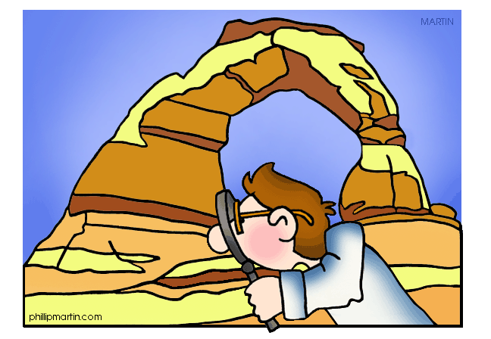
East Cobb Middle School has been around for quite some time. Ms. Colacicco said that evidence of weathering, erosion and deposition cannot be found because it takes millions of years for these things to happen. Elijah, Parker, Immanuel, and Robert think otherwise! They say that all these processes happen every day so we can definitely find these things around our campus! Help them prove Ms. Colacicco wrong by taking pictures of each of the following things below. In each box, describe what you see, what you think caused it, and where you found this.
PICTURE 1: Root Wedging  Mechanical or Chemical or other  How do you know this is root wedging? _______  ______________________________________________  ______________________________________________  What caused this? ___________________________  ______________________________________________  ______________________________________________  Description: __________________________________  ______________________________________________  ______________________________________________  ______________________________________________  ______________________________________________  Where did you find this? ______________________  ______________________________________________ | PICTURE 2: Ice Wedging  Mechanical or Chemical or other  How do you know this is ice wedging? _________  ______________________________________________  ______________________________________________  What caused this? ___________________________  ______________________________________________  ______________________________________________  Description: __________________________________  ______________________________________________  ______________________________________________  ______________________________________________  ______________________________________________  Where did you find this? ______________________  ______________________________________________
PICTURE 3: Oxidation  Mechanical or Chemical or other  How do you know this is oxidation? ____________  ______________________________________________  ______________________________________________  What caused this? ___________________________  ______________________________________________  ______________________________________________  Description: __________________________________  ______________________________________________  ______________________________________________  ______________________________________________  ______________________________________________  Where did you find this? ______________________  ______________________________________________ | PICTURE 4: Abrasion (Water)  Mechanical or Chemical or other  How do you know this is abrasion by water?  ______________________________________________  ______________________________________________  What caused this? ____________________________  ______________________________________________  ______________________________________________  Description: __________________________________  ______________________________________________  ______________________________________________  ______________________________________________  ______________________________________________  Where did you find this? ______________________  ______________________________________________
PICTURE 5: Abrasion (Gravity)  Mechanical or Chemical or other  How do you know this is abrasion by gravity?  ______________________________________________  ______________________________________________  What caused this? ___________________________  ______________________________________________  ______________________________________________  Description: __________________________________  ______________________________________________  ______________________________________________  ______________________________________________  ______________________________________________  Where did you find this? ______________________  ______________________________________________ | PICTURE 6: Animals  Mechanical or Chemical or other  How do you know this is deposition? ___________  ______________________________________________  ______________________________________________  What caused this? ____________________________  ______________________________________________  ______________________________________________  Description: __________________________________  ______________________________________________  ______________________________________________  ______________________________________________  ______________________________________________  Where did you find this? ______________________  ______________________________________________
PICTURE 7: Erosion  Mechanical or Chemical or other  How do you know this is erosion? ______________  ______________________________________________  ______________________________________________  What caused this? ___________________________  ______________________________________________  ______________________________________________  Description: __________________________________  ______________________________________________  ______________________________________________  ______________________________________________  ______________________________________________  Where did you find this? ______________________  ______________________________________________ | PICTURE 8: Deposition  Mechanical or Chemical or other  How do you know this is animals? ______________  _______________________________________________  _______________________________________________  What caused this? ____________________________  _______________________________________________  _______________________________________________  Description: ___________________________________  _______________________________________________  _______________________________________________  _______________________________________________  _______________________________________________  Where did you find this? _______________________  _______________________________________________

