WIND NOTES
Wind—horizontal movement of air from ________ to _______ pressure

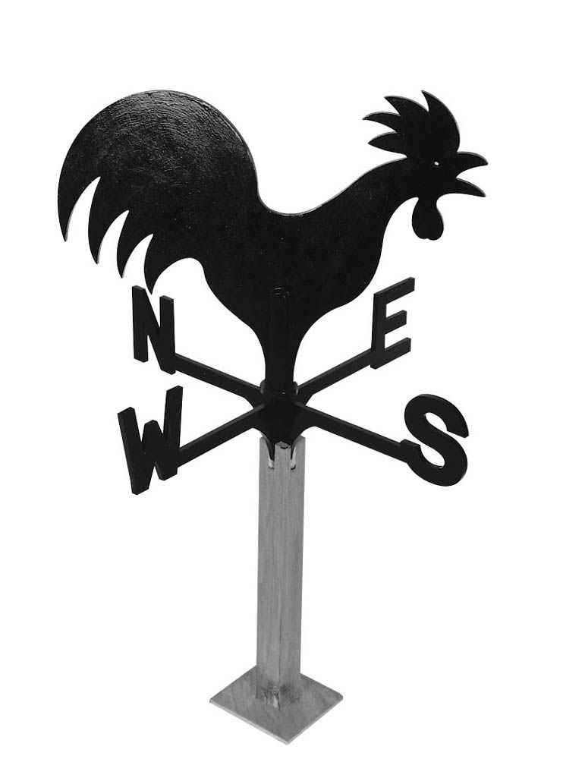Identify the wind instruments:

____________________ __________________
(wind speed) (wind direction)

Global winds:
Draw and label: Trade Winds, Prevailing Westerlies, and Polar Easterlies

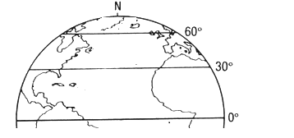

Coriolis Effect—winds appear to veer to the ______________because the earth spins.

Local winds (like sea and land breeze)—see handout and sand/water lab

